XXXXXXXXX[Title]
An NDSA Report
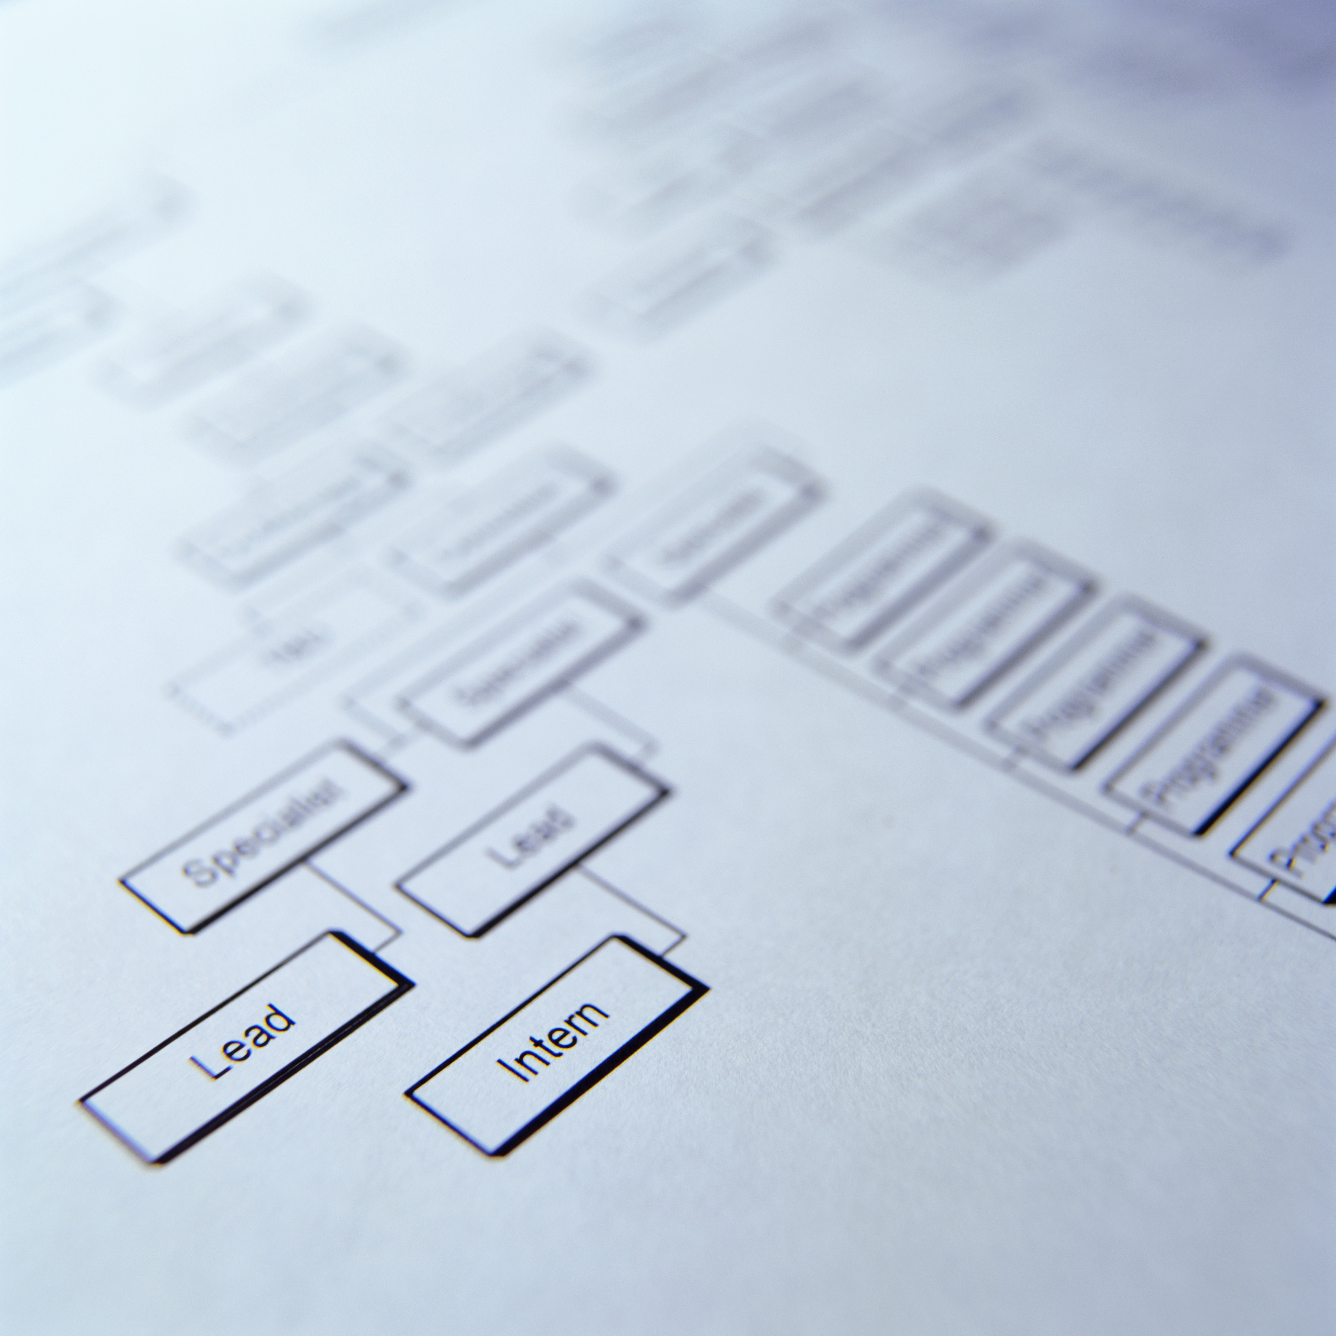

[target image size is 300 pixels wide by 300 pixels high)

December 2013 [Date] | Results of a Survey of Organizations Preserving Digital Content [subtitle if appropriate]
Authors [list name and affiliation but not title]
Doug Wingate, Taco Freedom University Libraries
Selvern McAdam, Vinyl Hoarder Institute
Etc. [can move things around to get this info on all this title page]
[statement of working group representation]Representing the NDSA Standards and Practices Working Group

Contents [sample TOC below, feel free to edit]
Executive Summary 3
About the National Digital Stewardship Alliance 3
Introduction 4
methodology 4
The Data Files 5
The Survey Codebook 5
Survey Content 6
FINDINGS 6
Background Information 7
Digital Content 8
Digital Preservation Activities 10
Digital Preservation Organization and Staffing 14
Staff Qualifications and Training 17
Comments about Digital Preservation Program Staffing and Organization 19
ANALYSIS 20
RELATED WORK 22
NEXT STEPS 23
CONCLUSION 23
REFERENCES 24
APPENDIX A -- SURVEY QUESTIONS 25
APPENDIX B – POSTER: iPRES 2012 at the University of Toronto 27

This work is licensed under a Creative Commons Attribution 3.0 Unported License.
Persistent URL: [persistent URL assigned by NDSA Secretariat]

Executive Summary
Lorem ipsum dolor sit amet, consectetur adipiscing elit. Aliquam venenatis eget risus sit amet ullamcorper. Nullam cursus scelerisque vulputate. Nam elementum augue vel adipiscing ornare. Donec ornare, ligula blandit aliquam vestibulum, magna quam pellentesque mi, eget euismod risus velit sed massa. Sed ligula mi, convallis a condimentum at, accumsan sed ante. In nec nibh vel enim laoreet aliquet sed a dui. Donec commodo, mauris vitae blandit adipiscing, odio metus venenatis massa, non blandit est quam in magna. Suspendisse lorem eros, fermentum sed leo vitae, gravida rutrum elit. Cras molestie sem neque, non placerat lorem mattis id. Class aptent taciti sociosqu ad litora torquent per conubia nostra, per inceptos himenaeos. Proin odio est, mattis in quam vel, ornare iaculis dui. Proin ullamcorper sem vel urna vulputate, et molestie ante euismod. Proin feugiat congue felis vel luctus.
Lorem ipsum dolor sit amet, consectetur adipiscing elit. Aliquam venenatis eget risus sit amet ullamcorper. Nullam cursus scelerisque vulputate. Nam elementum augue vel adipiscing ornare. Donec ornare, ligula blandit aliquam vestibulum, magna quam pellentesque mi, eget euismod risus velit sed massa. Sed ligula mi, convallis a condimentum at, accumsan sed ante. In nec nibh vel enim laoreet aliquet sed a dui. Donec commodo, mauris vitae blandit adipiscing, odio metus venenatis massa, non blandit est quam in magna. Suspendisse lorem eros, fermentum sed leo vitae, gravida rutrum elit. Cras molestie sem neque, non placerat lorem mattis id. Class aptent taciti sociosqu ad litora torquent per conubia nostra, per inceptos himenaeos. Proin odio est, mattis in quam vel, ornare iaculis dui. Proin ullamcorper sem vel urna vulputate, et molestie ante euismod. Proin feugiat congue felis vel luctus.
About the National Digital Stewardship Alliance [stays the same for each report]
Founded in 2010, the National Digital Stewardship Alliance (NDSA) is a consortium of institutions that are committed to the long-term preservation of digital information. NDSA’s mission is to establish, maintain, and advance the capacity to preserve our nation’s digital resources for the benefit of present and future generations. NDSA member institutions represent all sectors, and include universities, consortia, professional associations, commercial enterprises, and government agencies at the federal, state, and local levels.
More information about the NDSA is available from http://www.digitalpreservation.gov/ndsa/.

Level One Heading
Lorem ipsum dolor sit amet, consectetur adipiscing elit. Aliquam venenatis eget risus sit amet ullamcorper. Nullam cursus scelerisque vulputate. Nam elementum augue vel adipiscing ornare. Donec ornare, ligula blandit aliquam vestibulum, magna quam pellentesque mi, eget euismod risus velit sed massa. Sed ligula mi, convallis a condimentum at, accumsan sed ante. In nec nibh vel enim laoreet aliquet sed a dui. Donec commodo, mauris vitae blandit adipiscing, odio metus venenatis massa, non blandit est quam in magna. Suspendisse lorem eros, fermentum sed leo vitae, gravida rutrum elit. Cras molestie sem neque, non placerat lorem mattis id. Class aptent taciti sociosqu ad litora torquent per conubia nostra, per inceptos himenaeos. Proin odio est, mattis in quam vel, ornare iaculis dui. Proin ullamcorper sem vel urna vulputate, et molestie ante euismod. Proin feugiat congue felis vel luctus.

Level Two Heading
Lorem ipsum dolor sit amet, consectetur adipiscing elit. Aliquam venenatis eget risus sit amet ullamcorper. Nullam cursus scelerisque vulputate. Nam elementum augue vel adipiscing ornare. Donec ornare, ligula blandit aliquam vestibulum, magna quam pellentesque mi, eget euismod risus velit sed massa. Sed ligula mi, convallis a condimentum at, accumsan sed ante. In nec nibh vel enim laoreet aliquet sed a dui. Donec commodo, mauris vitae blandit adipiscing, odio metus venenatis massa, non blandit est quam in magna. Suspendisse lorem eros, fermentum sed leo vitae, gravida rutrum elit. Cras molestie sem neque, non placerat lorem mattis id. Class aptent taciti sociosqu ad litora torquent per conubia nostra, per inceptos himenaeos. Proin odio est, mattis in quam vel, ornare iaculis dui. Proin ullamcorper sem vel urna vulputate, et molestie ante euismod. Proin feugiat congue felis vel luctus codebook. [can either use footnotes or embedded linked URLs]
Level Two Heading
Lorem ipsum dolor sit amet, consectetur adipiscing elit. Aliquam venenatis eget risus sit amet ullamcorper. Nullam cursus scelerisque vulputate. Nam elementum augue vel adipiscing ornare. Donec ornare, ligula blandit aliquam vestibulum, magna quam pellentesque mi, eget euismod risus velit sed massa. Sed ligula mi, convallis a condimentum at, accumsan sed ante. In nec nibh vel enim laoreet aliquet sed a dui. Donec commodo, mauris vitae blandit adipiscing, odio metus venenatis massa, non blandit est quam in magna. Suspendisse lorem eros, fermentum sed leo vitae, gravida rutrum elit. Cras molestie sem neque, non placerat lorem mattis id. Class aptent taciti sociosqu ad litora torquent per conubia nostra, per inceptos himenaeos. Proin odio est, mattis in quam vel, ornare iaculis dui. Proin ullamcorper sem vel urna vulputate, et molestie ante euismod. Proin feugiat congue felis vel luctus codebook.
REFERENCES
APARSEN (2013). D36.1 Business Preparedness Report. Retrieved April 23, 2012, from http://www.alliancepermanentaccess.org/wp-content/uploads/downloads/2013/03/APARSEN-REP-D36_1-01-1_0.pdf
NDSA Standards and Practices Working Group (2012). “Who’s Minding the (Data) Store? Results of the NDSA Digital Preservation Staffing Survey.” Poster presented at iPRES 2012 at the University of Toronto http://www.digitalpreservation.gov/ndsa/documents/NDSA-staff-survey-poster-ipres2012.pdf
[ETC.]
APPENDIX A – your appendices
Lorem ipsum dolor sit amet, consectetur adipiscing elit. Aliquam venenatis eget risus sit amet ullamcorper. Nullam cursus scelerisque vulputate. Nam elementum augue vel adipiscing ornare. Donec ornare, ligula blandit aliquam vestibulum, magna quam pellentesque mi, eget euismod risus velit sed massa. Sed ligula mi, convallis a condimentum at, accumsan sed ante. In nec nibh vel enim laoreet aliquet sed a dui. Donec commodo, mauris vitae blandit adipiscing, odio metus venenatis massa, non blandit est quam in magna. Suspendisse lorem eros, fermentum sed leo vitae, gravida rutrum elit. Cras molestie sem neque, non placerat lorem mattis id. Class aptent taciti sociosqu ad litora torquent per conubia nostra, per inceptos himenaeos. Proin odio est, mattis in quam vel, ornare iaculis dui. Proin ullamcorper sem vel urna vulputate, et molestie ante euismod. Proin feugiat congue felis vel luctus.
glossary
[Glossary items should mirror, as much as possible, the NDSA glossary at http://www.digitalpreservation.gov/ndsa/ndsa-glossary.html. Suggests for revised glossary items or additions should be submitted to the NDSA secretariat so that we remain on roughly the same page]

A codebook is “a document that provides information on the structure, contents, and layout of a data file.” http://www.ddialliance.org/bp/definition. Accessed August 28, 2013.

